- Download the file to your computer.
- Right Click on any “.pdf” file that you wish to fill out.
- Click on “Open with Adobe Reader X”
(Click Here to download Adobe Reader if needed.)
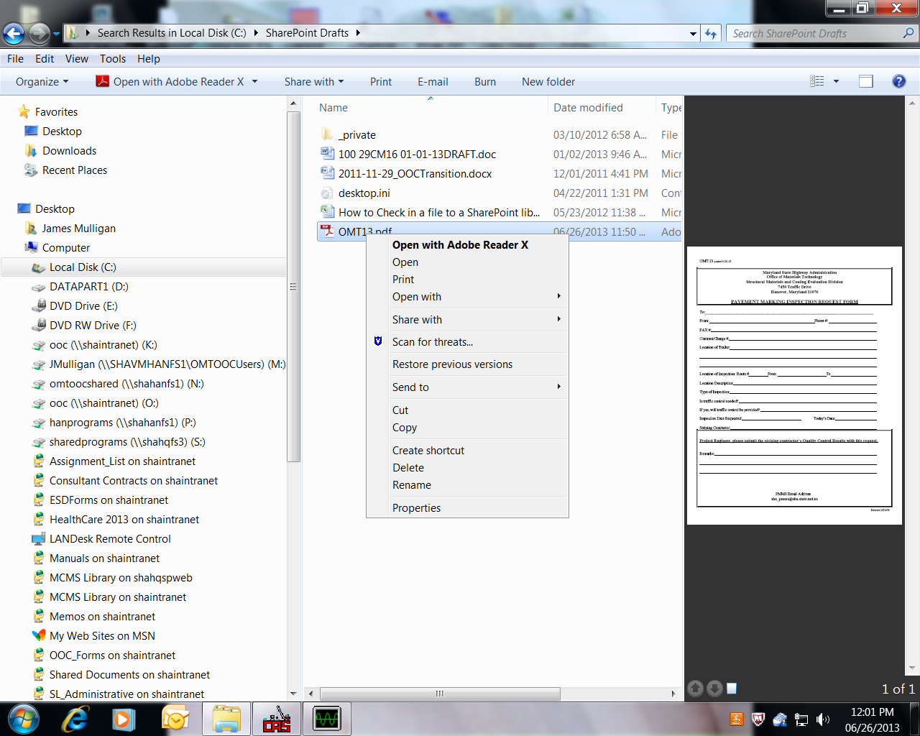
2.
1.

- From the upper right menu bar select the “Sign” tab. T
- then select “Add Text”
- From the “Add Text” menu that appears select the font and the font size that you wish to use.
(In most cases I choose font: “ Times New Roman” and font size “12”.)
- Place the cursor and type away.

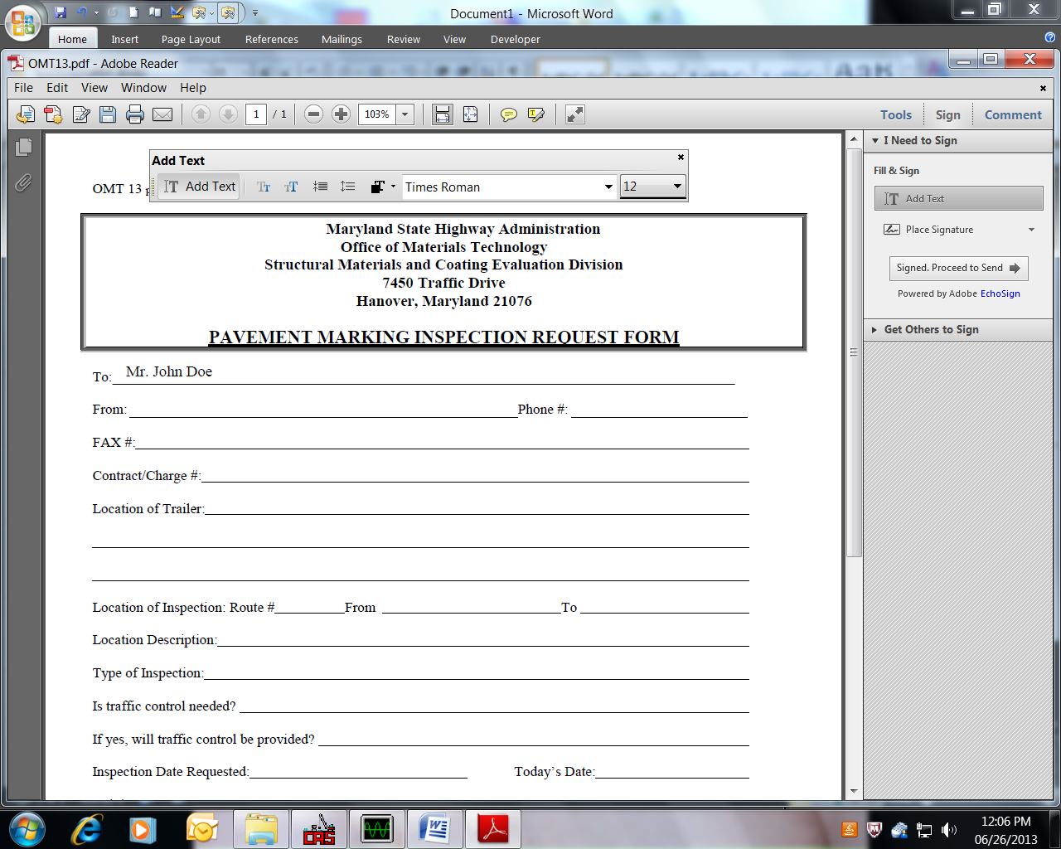
6.
7.
5.
4.
3.

- When form is complete select “File” then “Save As” from dropdown menu.
- Give file an appropriate name and save it in your documents folder or wherever.
- Name must be different than original form.

